**IBM PROJECT – PNT2022TMID26839**

**Team Leader**

B.MOHAN **(310519106038)**

**Team Members**

TAMILESHWARAN V **(310519106083)**

VARUN V **(310519106086)**

KAVIMRAJ S A **(310519106027)**

Bachelor of Engineering

In

Electronics and Communication Engineering

DHANALKSHMI SRINIVASAN COLLEGE OF ENGINEERING AND TECHNOLOGY MAMALLAPURAM, CHENNAI

# PROJECT REPORT

1. **INTRODUCTION:**

# Project Overview

* + - This challenge is primarily based on Internet of Things (iot), that can measure soil moisture, Humidity and temperature stipulations for agriculture and crop safety the use of Wastson IOT service. Iot is network that connects bodily objects or matters embedded with electronics, software program and sensors through community connectivity that collects and transfers records the usage oc loud for communication. Data is transferred through web barring human to human or human to pc interaction.
    - In this task we have now not used any hardware. Instead of actual soil moisture, Humidity and Temperature facts bought from sensosrs we make use o IBM IOT simulatore which can transmit these parameters as required.

# Purpose:

* + - An intelligent crop protection system helps the farmers in protecting the crop from the animals and birds which destroy the crop.
    - This system also helps farmers to monitor the soil moisture levels in the ﬁeld and also the temperature and humidity values near the ﬁeld. The motors and sprinklers in the ﬁeld can be controlled using the mobile application.

# LITERATURE SURVEY:

* 1. **Existing Problem**
     + Agriculture is a ﬁeld which forms the basis of our economy. Yet it faces a lot of problems in terms of availability of resources, Irrigation, increasing rate of Pesticides, Climatic disasters, Insects which ruin the crops and makes a huge loss this sector.
     + In agriculture water is needed for the crops for their growth. If the Soil gets dry it is necessary to supply water. But sometime if the farmer doesn't visit the ﬁeld it is not possible to know the condition of soil.
     + Sometimes over supply of water or less supply of water affects the growth of crops.
     + Sometimes if the weather/temperature changes suddenly it is necessary to take certain actions.
     + Crops grow better in speciﬁc conditions, they may get damaged due to bad weather.

# References

[1] ArturFrankiewicz; RafałCupek.” Smart Passive Infrared Sensor - Hardware Plat- form “Year: 2013 IECON 2013 - 39th Annual

Conference of the IEEE Industrial Electronics Society Pages: 7543 – 7547

[2] Discant, A. Rogozan, C. Rusu and A. Bensrhair, “Sensors for Obstacle Detection” 2007 30th International Spring Seminar on

Electronics Technology (ISSE), Cluj-Napoca, 2007, pp. 100-105. doi: 10.1109/ISSE.2007.4432828 Volume:01 Pages:859-862,

DOI:10.1109/ICCSNT.2015.7490876, IEEE Conference Publications.

[3] Mustapha, Baharuddin, AladinZayegh, and Rezaul K. Begg. “Ultrasonic And Infrared Sensors Performance in A Wireless Obstacle

Detection System” Artificial Intelligence, Modelling and Simulation (AIMS), 2013 1st International Conference on. IEEE, 2013.

[4] Padmashree S. Dhake, Sumedha S. Borde, “Embedded Surveillance System Using PIR Sensor”, International Journal of Advanced

Technology in Engineering and Science, www.ijates.com Volume No.02, Issue No. 03, March 2014.

# Problem Statement Definition

* + - Smart Crop Protection System based on IoT can monitor soil moisture and climatic conditions to grow and yield a good crop.
    - The farmer can also get the real time weather forecasting data by using external platforms like Open Weather API.
    - Farmer is provided a mobile app using which he can monitor the temperature ,humidity and soil moisture parameters along with weather forecasting details.
    - Based on all the parameters he can water his crop by controlling the motors using the mobile application.
    - Even if the farmer is not present near his crop he can water his crop by controlling the motors using the mobile application from anywhere.
    - Here we are using the Online IoT simulator for getting the Temperature, Humidity and Soil Moisture values.

# IDEATION & PROPOSED SOLUTION:

* 1. **Empathy Map Canvas**

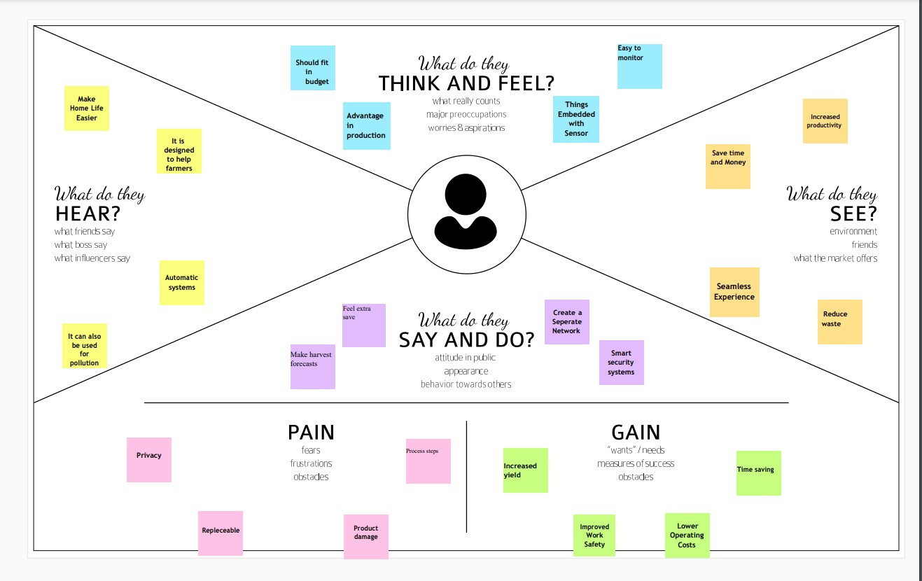

# Ideation & Brain Storming

What do they think and feel?

As its name may imply, smart farming is the use of technology in animal agriculture, and it’s something that’s been around since the Industrial Revolution. The biggest difference between then and now, though? “Motorized devices are being replaced with IOT”.

What do they hear?

Smart farming is about using the new technologies which have arisen at the dawn of the Fourth Industrial Revolution in the areas of agriculture and cattle production to increase production quantity and quality, by making maximum use of resources and minimizing the environmental impact.

What do they see?

Smart farming is a management concept focused on providing the agricultural industry with the infrastructure to leverage advanced technology – including big data, the cloud and the internet of things (IoT) – for tracking, monitoring, automating and analyzing operations.

What do they say and do?

* The aim of this technology is to make the most of all the data collected by various tools, by converting them into real sources of information in order to then define ways of simplifying agricultural work. It also allows for accurate and predictive analysis
* of all situations that may affect the farms, such as weather conditions (temperature, humidity, etc.) and sanitary or economic situations, for example. This makes it easier to organize the supply of energy, water, livestock feed and fertilizer.
* In its most advanced form, smart farming facilitates the exchange of information between different farms, creating a real network of connected farms accessible from a
* smartphone .

# Proposed Solution

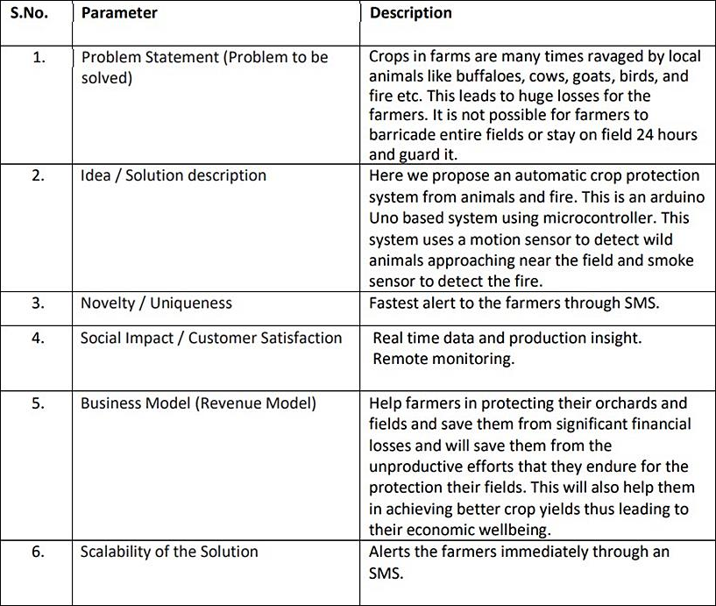

* 1. **Problem Solution Fit**

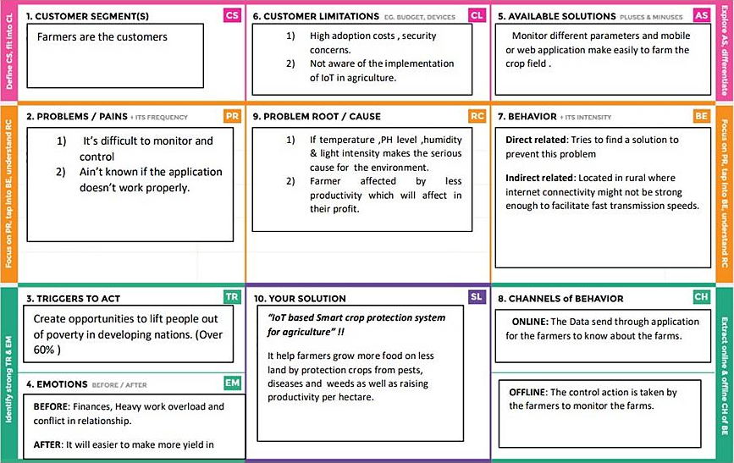

# REQUIREMENT ANALYSIS:

* 1. 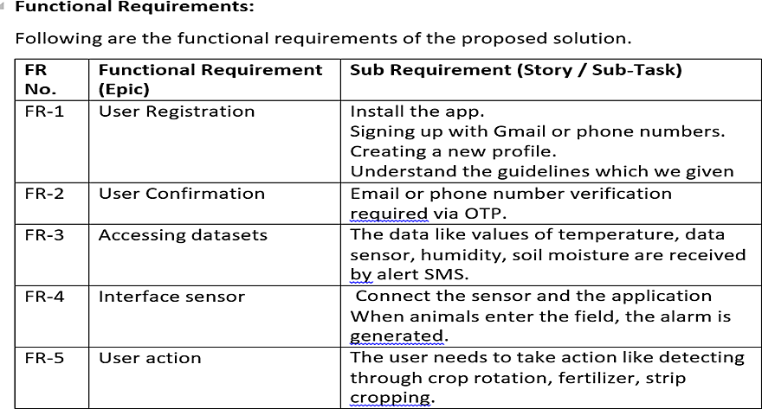**Functional Requirements**

# Non Functional Requirements

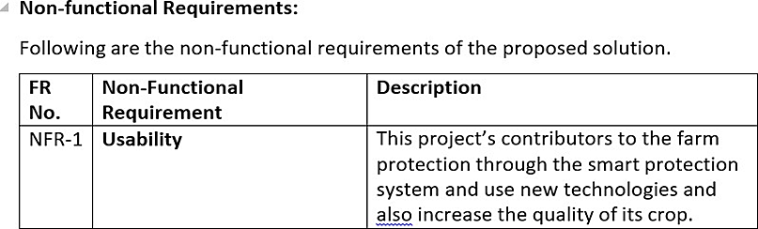

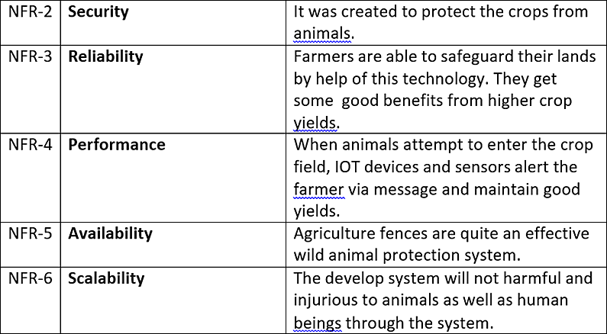

1. **PROJECT DESIGN**:

# Data Flow Diagram

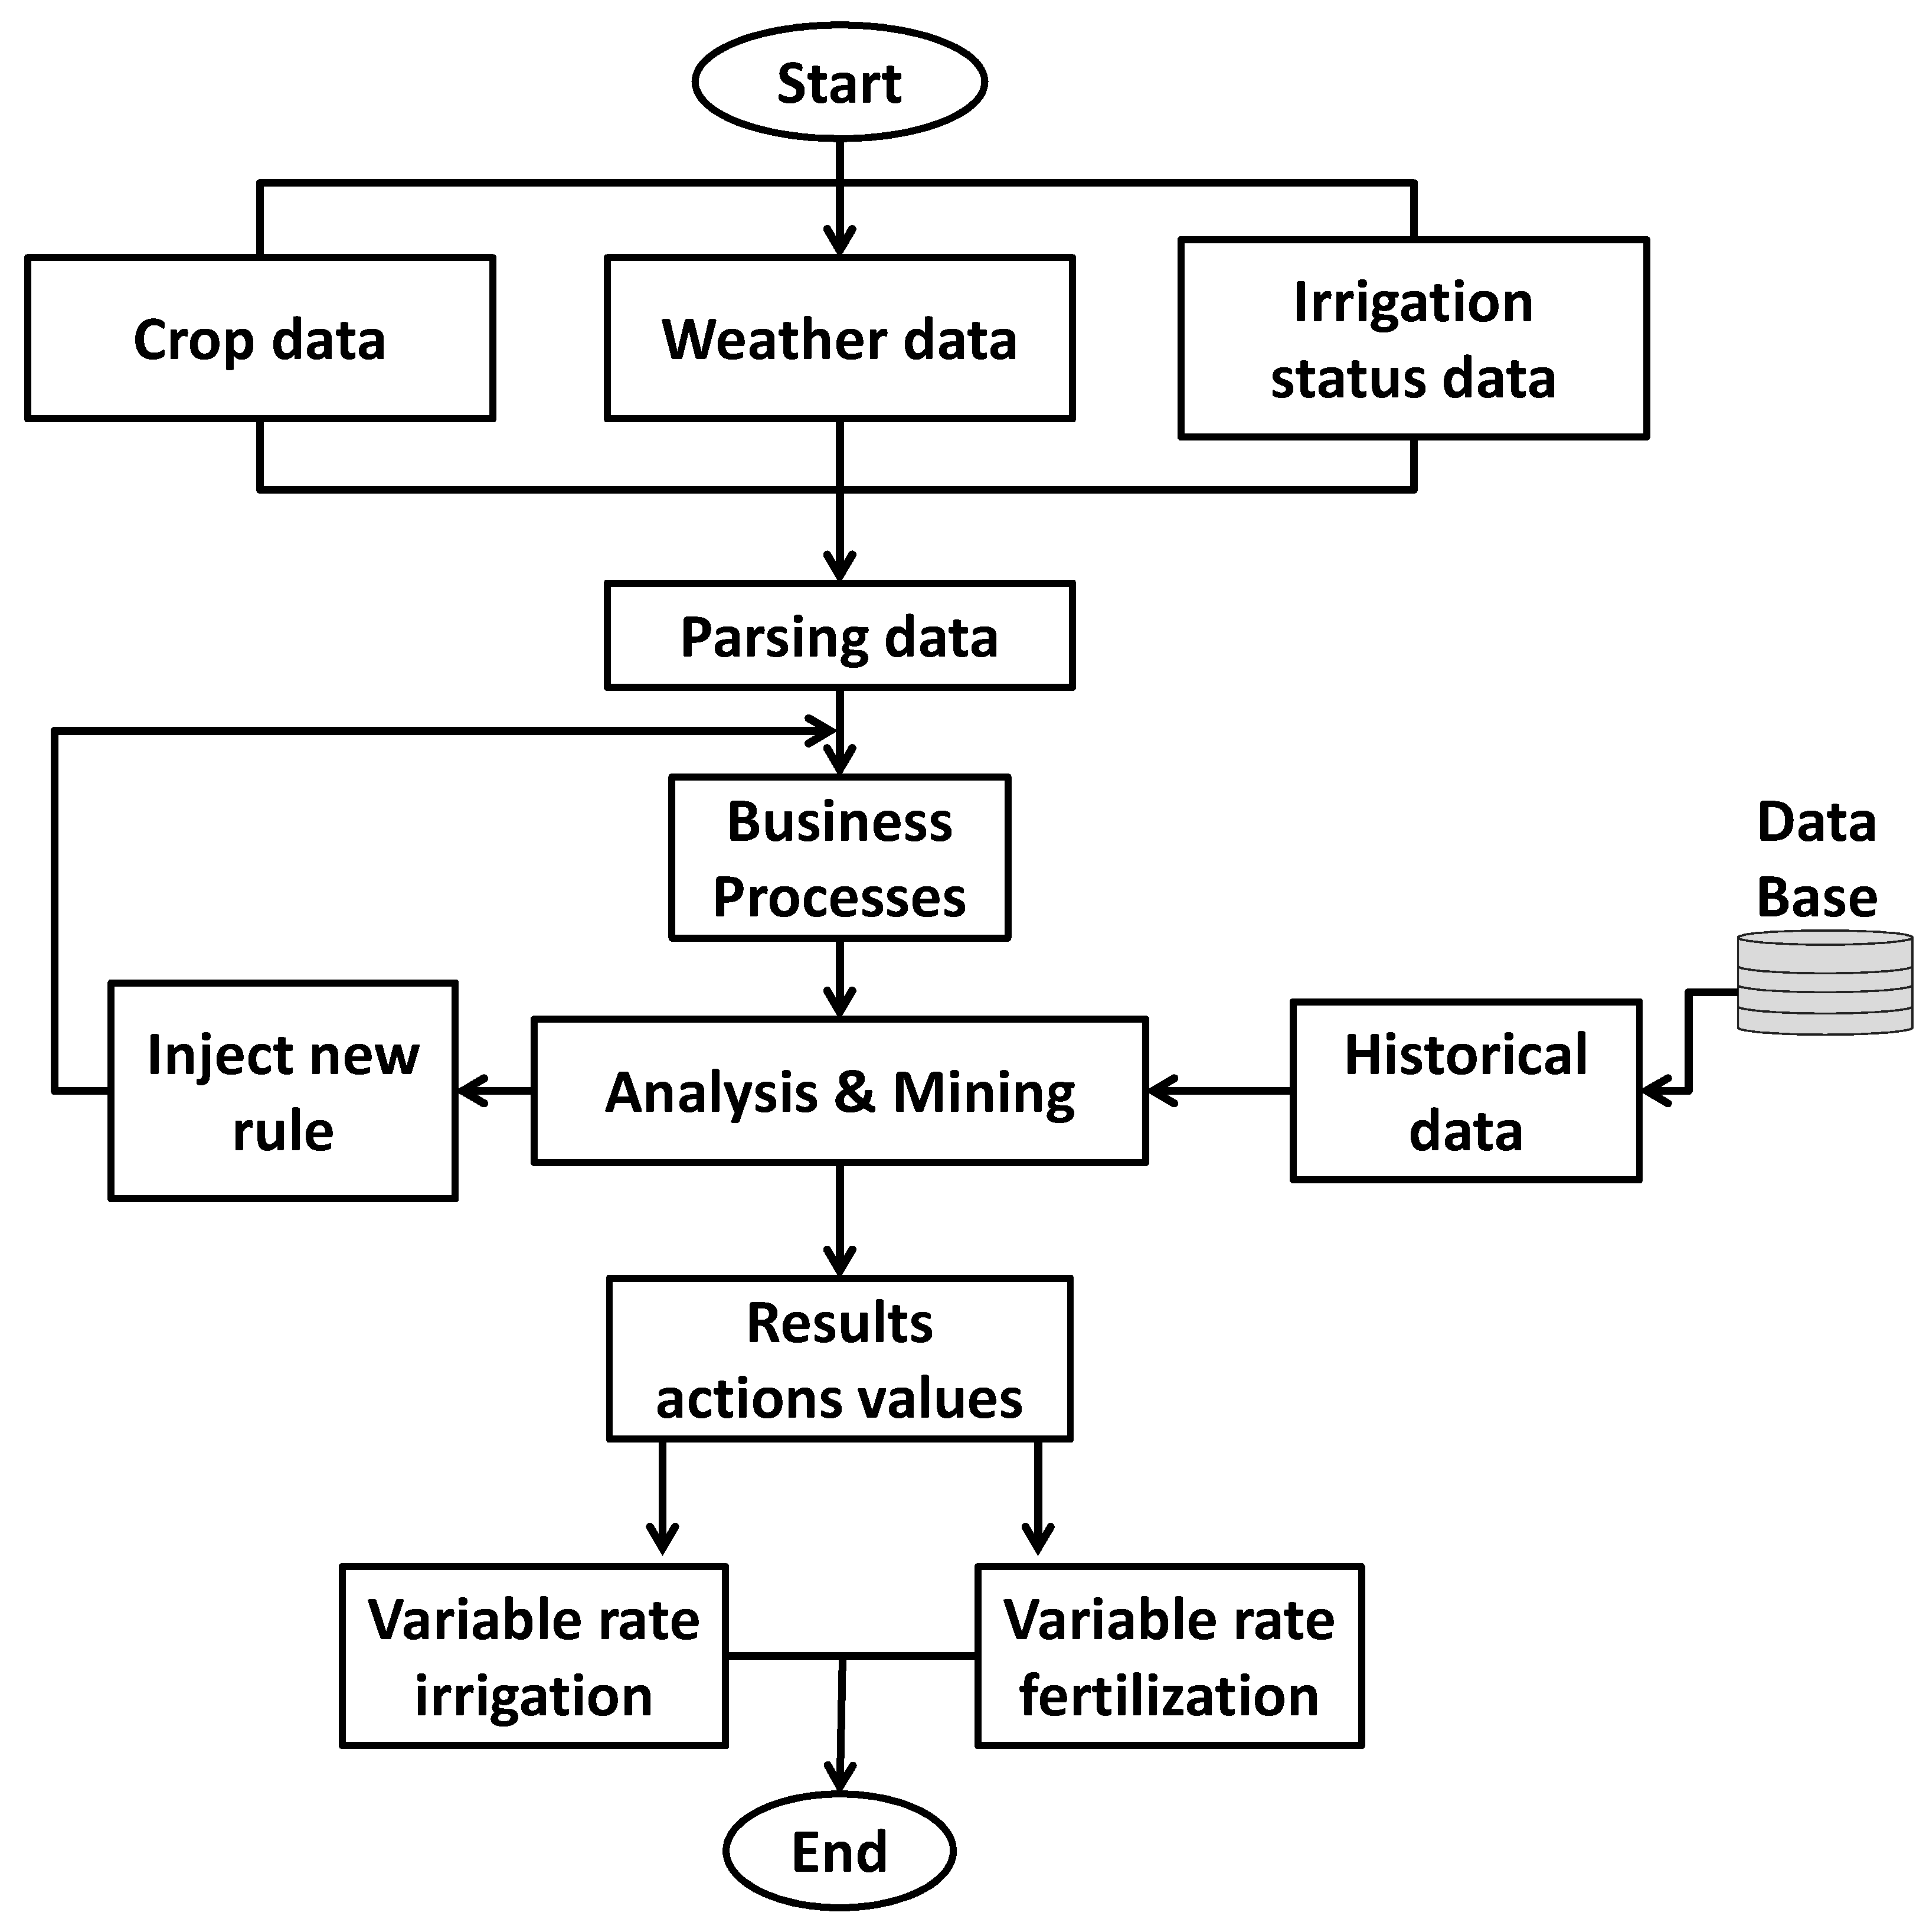

* 1. **Solution & Technical Architecture**

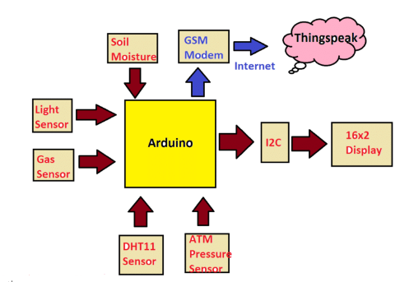

# User Stories

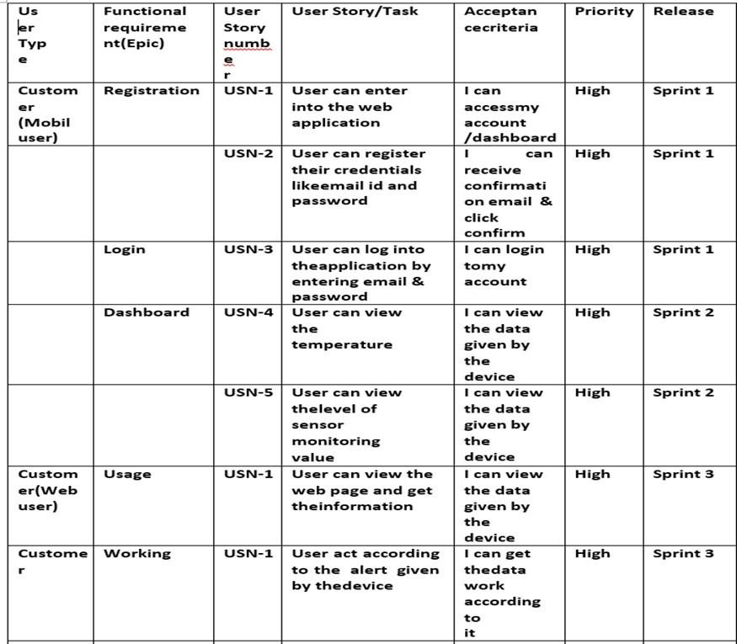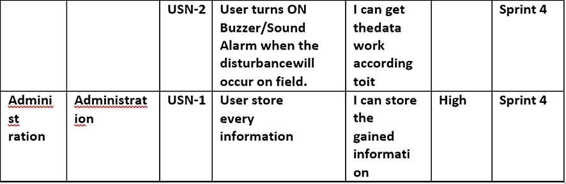

1. **PROJECT PLANNING& SCHEDULING**

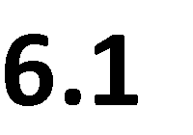

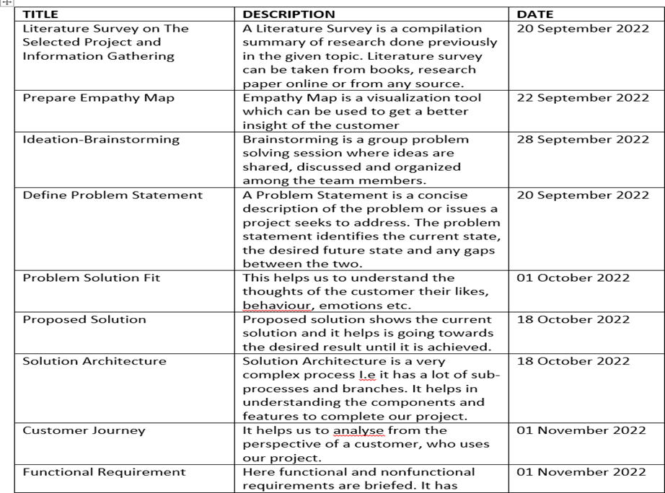

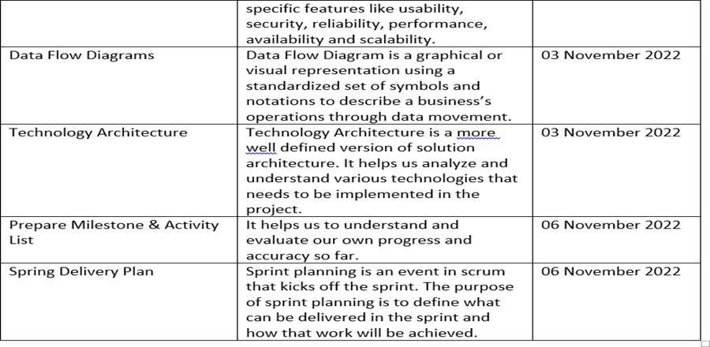

# 6.2 Sprint Delivery Schedule

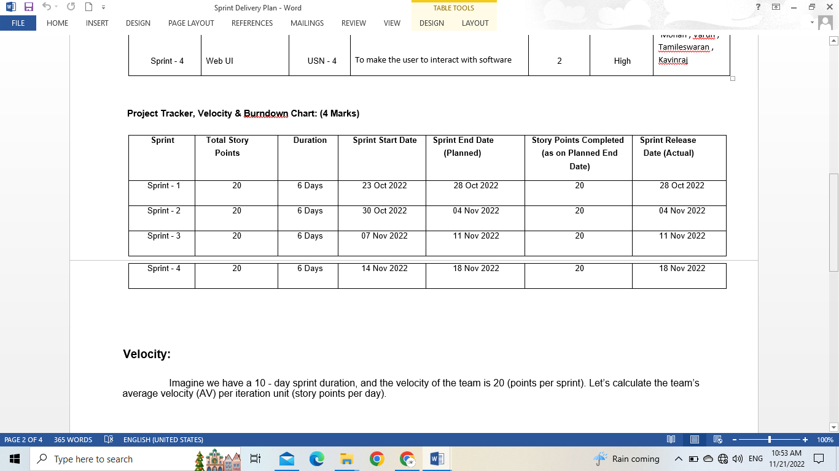

**Velocity:**

Imagine we have a 10 - day sprint duration, and the velocity of the team is 20 (points per sprint). Let’s calculate the team’s average velocity (AV) per iteration unit (story points per day).

**AV= Sprint duration/Velocity =20/10=2**

**Burn down Chart:**

A burn down chart is a graphical representation of work left to do versus time. It is often used in agile software development methodologies such as scrum. However, burn down charts can be applied to any project containing measurable progress over time.

1. **CODING & SOLUTIONING:**

# Feature 1

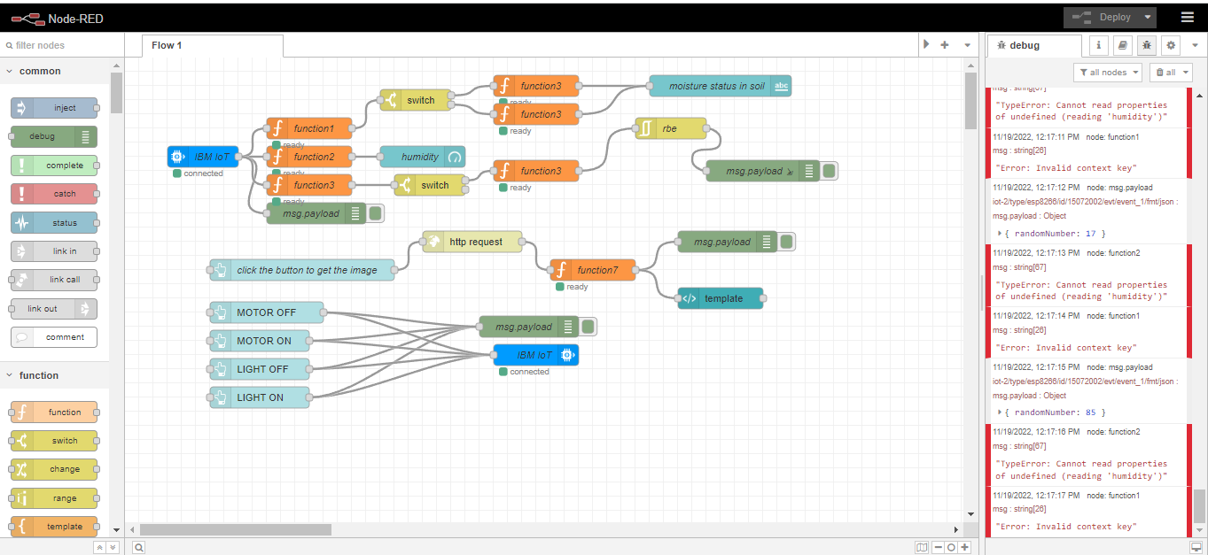

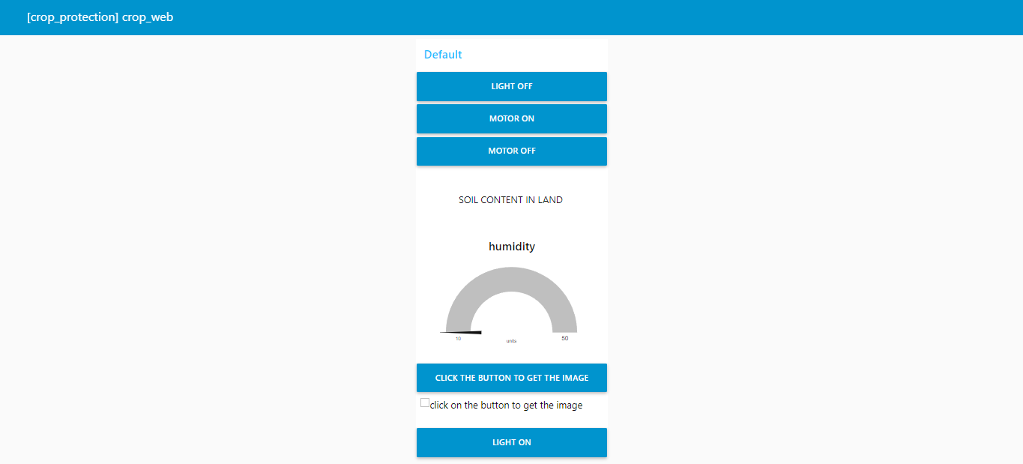

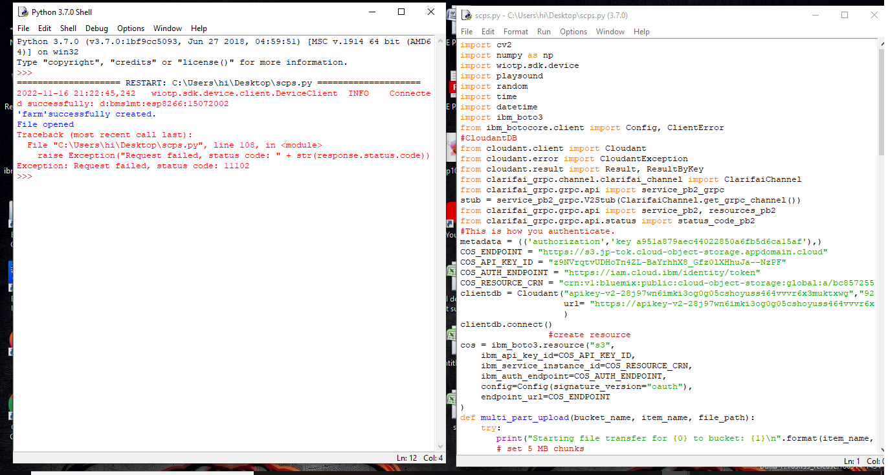

# TESTING:

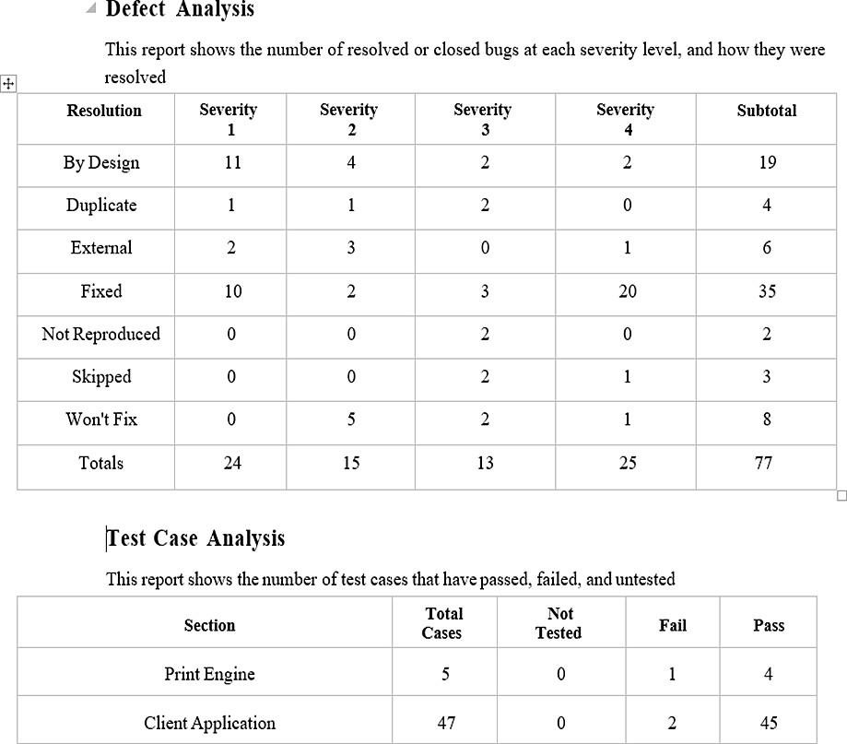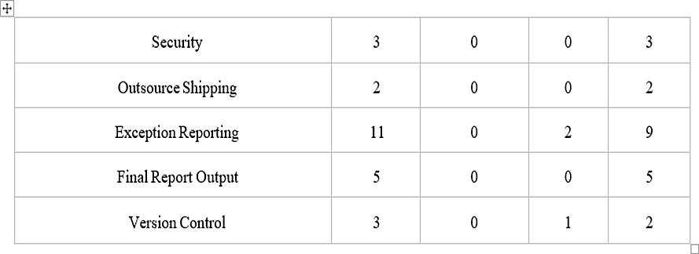

1. **RESULT:**

We have successfully built an IOT Based Smart Crop Protection System forAgriculture and integrated all the services using Node-RED.

# ADVANTAGES & DISADVANTAGES:

* 1. **Advantages**
     + All the data like climatic conditions and changes in them, soil or crop conditions everything can be easily monitored.
     + Risk of crop damage can be lowered to a greater extent.
     + Many diﬃcult challenges can be avoided making the process automated and the quality of crops can be maintained.
     + The process included in farming can be controlled using the web applications from anywhere, anytime.

# Disadvantages

* + - Smart Crop Protection requires internet connectivity continuously, but rural part scan not full ﬁll this requirement.

1. Any faults in the sensors can cause great loss in the agriculture, due to wrong records and the actions of automated processes.
2. IoT devices need much money to implement.

# CONCLUSION:

IoT based smart Crop Monitoring System for Agriculture for Live Monitoring of Temperature and Soil Moisture and to control motor and light remotely has been proposed using Node Red and IBM Cloud Platform. The System has high efficiency and accuracy in fetching the live data of temperature and soil moisture. The IoT based smart farming System being proposed via this project will assist farmers in increasing the agriculture yield and take efficient care of food production as the System will always provide helping hand to farmers for getting accurate live feed of environmental temperature and soil moisture with more than 99% accurate results. Therefore, the project proposes a thought of consolidating the most recent innovation into the agrarian field to turn the customary techniques for water system to current strategies in this way making simple profitable and temperate trimming.

# FUTURE SCOPE:

In future due to more demand of good and more farming in less time, for betterment of the crops and reducing the usage of extravagant resources like electricity and water IoT can be implemented in most of the places.

# APPENDIX:

GITHUB LINKhttps://github.com/IBM-EPBL/IBM-Project-38133-1660372925

VIDEO LINK :